Renzi’s hidden problem: the brain drain
February 27, 2014 1:35 pm by Valentina Romei
65inShare8 13
Elena is a 26 year old Italian woman with a degree in child psychology who has been working in London as a nursery teacher for nearly a year. She moved to the UK after months spent looking in vain for a job in Tuscany, a region where the unemployment rate, at 7.9%, is well below the Italian average of 11.3%.
But Elena is not counted among more than 16,000 Italians that moved to the UK, according to official statistics updated for the FT by the Italian Ministry of Interior. These numbers are based on the registry of Italians living abroad (AIRE). Elena has a vague knowledge of this register but decided not to sign up for fear of losing important rights and services (including healthcare) in her home country.
However, Elena is not invisible in all government statistics. She appears among the Italians requesting a National Insurance Number (NINo) in order to be able to work in the UK. The latest data, released on 27 February, reveals that over 44,000 Italians were allocated a number last year. That is nearly three times the Italian official figure for emigrants to the UK.
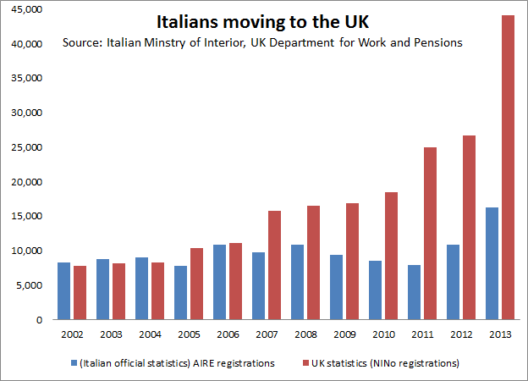
Regardless of the anomaly in the data sources a trend is clear: the number of Italians moving out of the country is rising massively. National Insurance numbers allocated to Italians in the UK last year were 66% higher than in 2012, the largest increase of any of the top 20 nationalities.
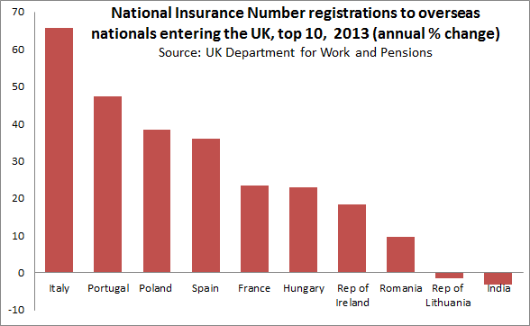
Like Elena, Italians moving to the UK tend to be young and skilled. Over 80% of the people that were allocated a NINo last year were below 34 years old. 42% were aged between 18 and 24, a rapid increase from pre-crisis levels of around 30%.
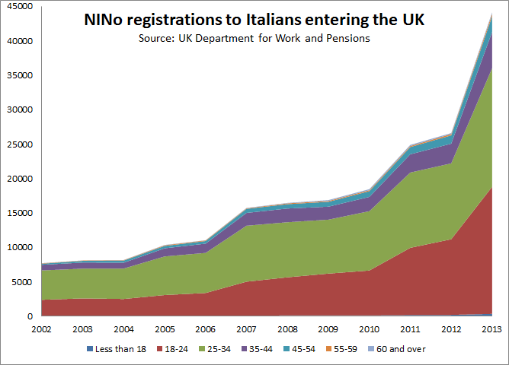
But the Italian diaspora is much larger than these figures suggest. The UK is only the fifth largest European destination of emigrants after Germany, Switzerland, France and Belgium.
The new – and young – Italian Prime Minister Matteo Renzi, former major of Florence, might have raised hopes of young Italians by promising radical reforms, including a “jobs act”, a proposal aimed at boosting the labour market, by talks of a renewal of the education system and a massive process of simplification in the bureaucracy. But it is not yet clear how Renzi is planning to achieve these goals.
Skilled young Italians would be an important resource for a country where the proportion of older people (over 65) is the third largest in the world after Japan and Germany and the proportion of the population who attained tertiary education is the second lowest among OECD countries after Turkey.
While politicians ponder reforms, the most promising part of the workforce is moving to other countries. Elena would like to eventually go back to Italy, but when asked what she would do if she does not find a job in her home country, she simply answers “I’ll stay in London”.
Posted in Data, Demographics, Economics, Italy, UK | Permalink

